Tales Of Vesperia DB

Nathan Fahrner

Executive Summary

This database tracks all equipment and items of all types, and their synthesis components. Artes, skills, and titles are also tracked. This is to allow user to see what elements their missing in their collectors book, and plan item synthesis. The admin is able to edit tables, but users can only
The database is described below by a ERD diagram, type definitions, table listings, views, and stored procedures. Some sample data has been altered for ease of testing.

ER Diagram

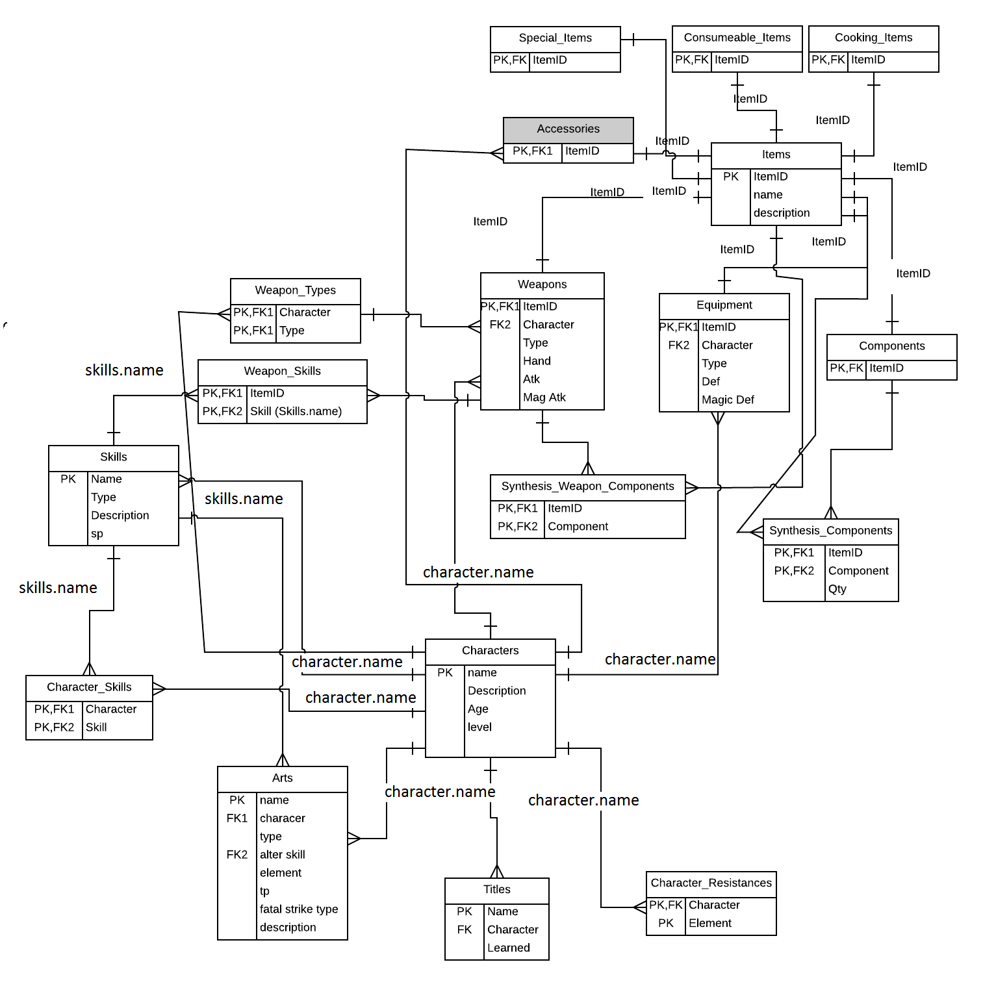

Enum Types

CREATE TYPE TYPE_ELEMENT AS ENUM ( 'fire','water','wind','earth','light','darkness', 'none' );

CREATE TYPE TYPE_ART AS ENUM ( 'base', 'arcane', 'altered', 'burst', 'novice spell','intermediate spell','advanced spell');

CREATE TYPE TYPE_FATAL_STRIKE AS ENUM ('red', 'blue', 'green', 'none');

CREATE TYPE TYPE_SKILL AS ENUM ( 'attack', 'defense', 'agility', 'constitution' );

CREATE TYPE TYPE_WEAPON AS ENUM( 'main', 'off hand' );

CREATE TYPE TYPE_ARMOR AS ENUM ( 'helmet' , 'armor' );

Tables

Characters
This table just tracks characters for use in other tables.

CREATE TABLE characters (
name TEXT NOT NULL,
PRIMARY KEY(name)
);

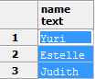

Character_Resistances
Shows character elemental weaknesses.

CREATE TABLE character_resistances(
character TEXT NOT NULL REFERENCES characters(name),
element TYPE_ELEMENT NOT NULL DEFAULT 'none',
PRIMARY KEY( character,element )
);

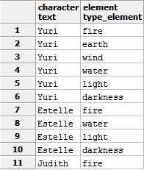

Skills
Contains skill data.

CREATE TABLE skills (
name TEXT NOT NULL,
type TYPE_SKILL NOT NULL,
sp INT NOT NULL CHECK (sp > 0),
description TEXT NOT NULL,
PRIMARY KEY(name)
);

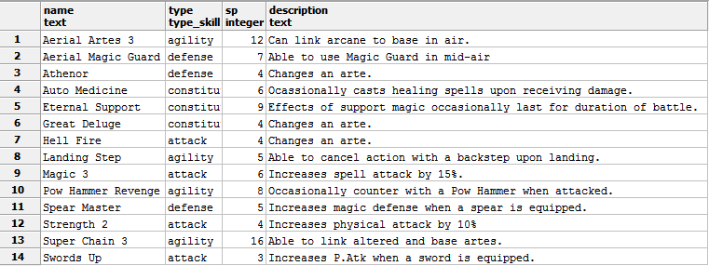

Character_Skills
Relates skills to what characters can learn them.

CREATE TABLE character_skills(
character TEXT NOT NULL REFERENCES characters(name),
skill TEXT NOT NULL REFERENCES skills(name),
PRIMARY KEY(character,skill)
);

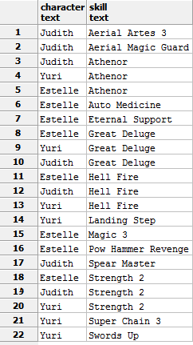

Weapon_Types

Describes available weapon types for weapons table.

CREATE TABLE weapon_types (
character TEXT NOT NULL REFERENCES characters(name),
type TEXT NOT NULL,
PRIMARY KEY(character,type)
);

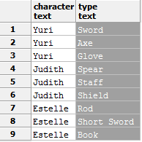
Titles
Contains character titles.

CREATE TABLE titles(
name TEXT NOT NULL,
character TEXT NOT NULL REFERENCES characters(name),
PRIMARY KEY(name)
);

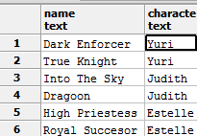

Artes
Contains character artes data.

CREATE TABLE artes (
name TEXT NOT NULL,
character TEXT NOT NULL REFERENCES characters(name),
type TYPE_ART NOT NULL,
alter_skill TEXT REFERENCES skills(name),
element TYPE_ELEMENT NOT NULL DEFAULT 'none',
tp INT NOT NULL CHECK( tp >= 0 ),
fatal_strike_type TYPE_FATAL_STRIKE NOT NULL DEFAULT 'none',
description TEXT NOT NULL,
PRIMARY KEY(name)
);

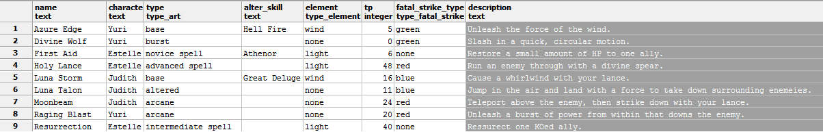

Items
Base table for all item types.

CREATE TABLE items(
itemid INT NOT NULL CHECK( itemid > -1 ),
name TEXT NOT NULL,
description TEXT NOT NULL,
PRIMARY KEY(itemid)
);

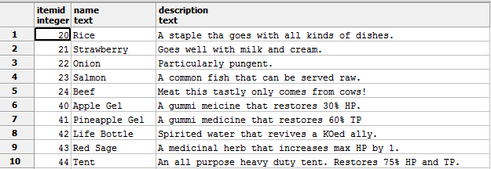

Cooking_Items
Contains all cooking items.

CREATE TABLE cooking_items(
itemid INT NOT NULL REFERENCES items(itemid),
PRIMARY KEY(itemid)
);

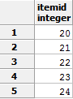

Consumable_Items

Contains consumable items.

CREATE TABLE consumable_items(
itemid INT NOT NULL REFERENCES items(itemid),
PRIMARY KEY(itemid)
);

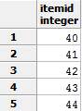

Special_Items
Contains special items.

CREATE TABLE special_items(
itemid INT NOT NULL REFERENCES items(itemid),
PRIMARY KEY(itemid)
);

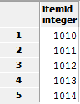

Components
Contains synthesis components.

CREATE TABLE components(
itemid INT NOT NULL REFERENCES items(itemid),
PRIMARY KEY(itemid)
);

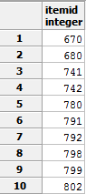

Accessories
Contains accessories items.

CREATE TABLE accessories(
itemid INT NOT NULL REFERENCES items(itemid),
PRIMARY KEY(itemid)
);

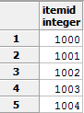

Weapons
Contains weapon data, gets weapon type from weapon_types. Can be main or off hand weapon.

CREATE TABLE weapons(
itemid INT NOT NULL REFERENCES items(itemid),
character TEXT NOT NULL,
type TEXT NOT NULL,
hand TYPE_WEAPON NOT NULL,
atk INT NOT NULL CHECK (atk >= 0),
mag_atk INT NOT NULL CHECK (mag_atk >= 0),
FOREIGN KEY (character,type)
REFERENCES weapon_types(character,type),
PRIMARY KEY(itemid)
);

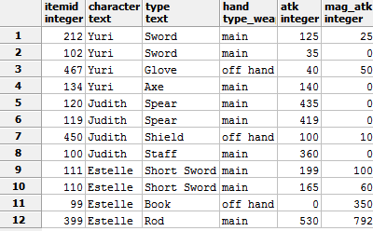

Equipment
Stores armor and helmets, links character form character table.

CREATE TABLE equipment(
itemid INT NOT NULL REFERENCES items(itemid),
character TEXT NOT NULL REFERENCES characters(name),
type TYPE_ARMOR NOT NULL,
def INT NOT NULL CHECK (def >= 0),
mag_def INT NOT NULL CHECK (mag_def >= 0),
PRIMARY KEY(itemid)
);

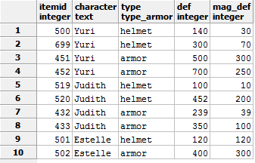

Synthesis_Components
This table lists items and their synthesis components, along with qty needed.

CREATE TABLE synthesis_components(
itemid INT NOT NULL REFERENCES items(itemid),
component INT NOT NULL REFERENCES components(itemid),
qty INT NOT NULL CHECK (qty > 0),
PRIMARY KEY(itemid,component)
);

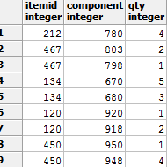

Synthesis_Weapon_Components
This table list item synth components that are weapons. All qty's are 1.

CREATE TABLE synthesis_weapon_components(
itemid INT NOT NULL REFERENCES items(itemid),
component INT NOT NULL REFERENCES weapons(itemid),
PRIMARY KEY(itemid,component)
);

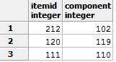

Weapon_Skills
Links skills learned from various weapons.

CREATE TABLE weapon_skills(
itemid INT NOT NULL REFERENCES items(itemid),
skill TEXT NOT NULL REFERENCES skills(name),
PRIMARY KEY(itemid,skill)
);

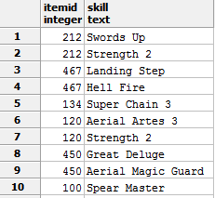

Views

View All Main Weapons
Views all main hand weapons and their data.

CREATE OR REPLACE VIEW ViewAllMainHandWeapons AS
SELECT weapons.*,items.name,items.description from items
INNER JOIN weapons ON weapons.itemid = items.itemid
WHERE weapons.hand = 'main'
ORDER BY weapons.character, items.itemid ASC;

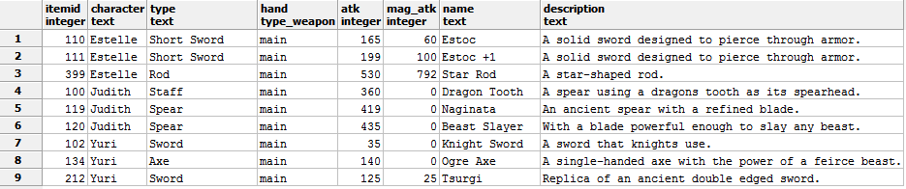

View All Off Hand Weapons
Views all off hand weapons and their data.

CREATE OR REPLACE VIEW ViewAllOffHandWeapons AS
SELECT weapons.*,items.name,items.description from items
INNER JOIN weapons ON weapons.itemid = items.itemid
WHERE weapons.hand = 'off hand'
ORDER BY weapons.character, items.itemid ASC;

View All Helmets
Views all helmets and their data.

CREATE OR REPLACE VIEW ViewAllHelmets AS
SELECT equipment.*,items.name,items.description from items
INNER JOIN equipment ON equipment.itemid = items.itemid
WHERE equipment.type = 'helmet'
ORDER BY equipment.character, items.itemid ASC;

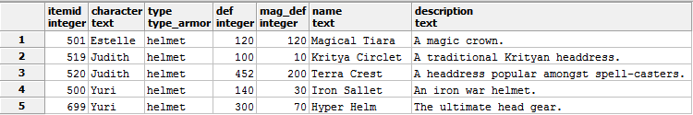

View All Armor
Views all armor and its data.

CREATE OR REPLACE VIEW ViewAllArmor AS
SELECT equipment.*,items.name,items.description from items
INNER JOIN equipment ON equipment.itemid = items.itemid
WHERE equipment.type = 'armor'
ORDER BY equipment.character, items.itemid ASC;

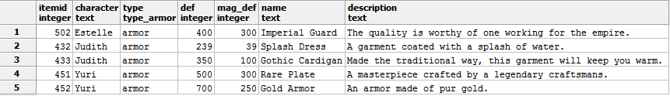

View All Accessories
Views all accessory data.

CREATE OR REPLACE VIEW ViewAllAccessories AS
SELECT accessories.*,items.name,items.description from items
INNER JOIN accessories ON accessories.itemid = items.itemid
ORDER BY items.name ASC;

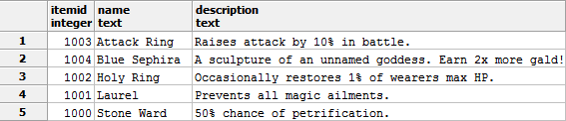

View All Special Items
Lists all special items and data.

CREATE OR REPLACE VIEW ViewAllSpecialItems AS
SELECT special_items.*,items.name,items.description from items
INNER JOIN special_items ON special_items.itemid = items.itemid
ORDER BY items.name ASC;

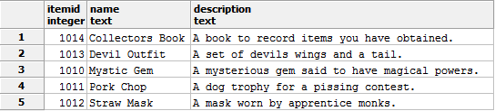

View All Cooking Items
Lists all cooking items.

CREATE OR REPLACE VIEW ViewAllcookingitems AS
SELECT cooking_items.*,items.name,items.description from items
INNER JOIN cooking_items ON cooking_items.itemid = items.itemid
ORDER BY items.name ASC;

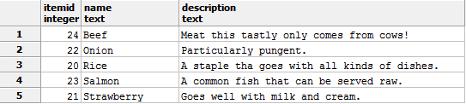

View All Consumable Items
Lists all consumable items.

CREATE OR REPLACE VIEW ViewAllconsumableitems AS
SELECT consumable_items.*,items.name,items.description from items
INNER JOIN consumable_items ON consumable_items.itemid = items.itemid
ORDER BY items.name ASC;

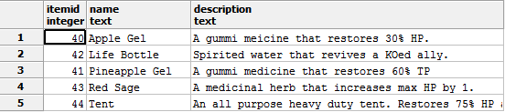

Security

Admin has full access, while a public user can only view data.

CREATE ROLE admin;
GRANT SELECT,INSERT,UPDATE,DELETE ON ALL TABLES IN SCHEMA PUBLIC
TO admin;

CREATE ROLE public;
GRANT SELECT ON ALL TABLES IN SCHEMA PUBLIC
TO public;

